

**Wanted:** Ph.D. student or postdoctoral fellow with background in population genetics / computational biology / statistics for an

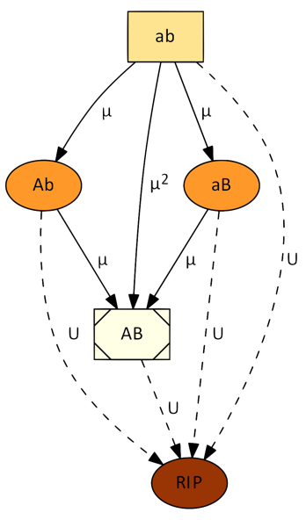 **ERC-funded project at Stern Lab** (Life Sciences, Tel Aviv University) in collaboration with Ram Lab (Computer Science, IDC Herzliya). The project involves designing, implementing, and testing a new statistical inference approach for evolutionary experiments of RNA viruses. The method will use **evolutionary simulations and cutting-edge** **deep learning** **algorithms**. Potential candidates should email Dr. Adi Stern (sternadi@tau.ac.il) and Dr. Yoav Ram (yoav@yoavram.com) with CV (including publication list), letter of interest specifying their background and scientific interests, and contact for at least two recommendations. Position is open effective immediately and duration is flexible.